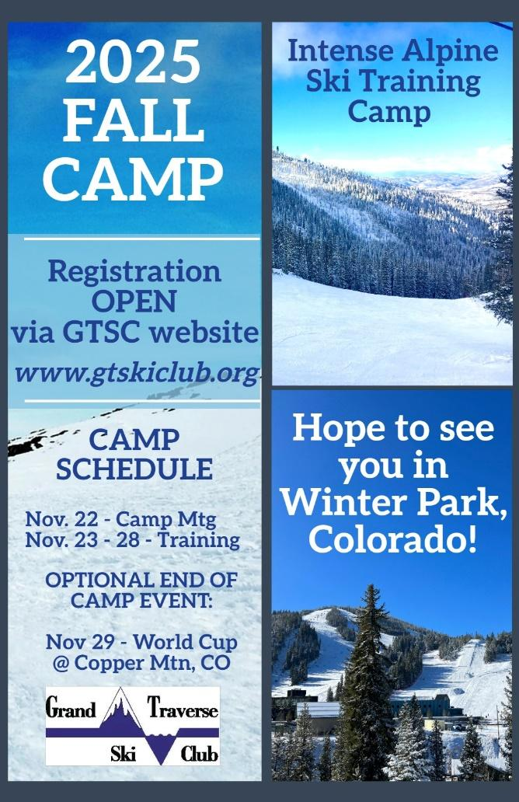
BENSLEY MEMORIAL SCHOLARSHIP APPLICATION
GTSC 2025 Fall Camp Trip to Winter Park, CO
Application DUE: September 20, 2025
Email completed applications to: skigtsc@gmail.com
Camp Dates: November 22 - 28, 2025 (Nov 29 add’l add-on)
The GTSC Fall Ski Camp scholarship is for one athlete & includes:
- Coaching (on-snow Nov 23-28)
- Training (on-snow Nov 23-28)
- Dryland Training (Nov 23-28)
- Video Sessions (Nov 23-28)
- Accommodations (Arrive eve Nov 22-Depart morn of 29)
- Food (Arrive eve Nov 22 - Depart morning Nov 29)
To be eligible to apply for this opportunity, the applicant must:
- Be a current or former member of GTSC;
- Be entering 9-12 grade this upcoming season and committed to ski for their High School Ski Team;
- Pay for transportation to/from Winter Park;
- Pay for all other meals/expenses not included in timeframe above and/or while at the Camp.
APPLICANT QUESTIONAIRE (all sections must be completed by applicant for consideration):
Full Name: __________________________________________________________________________________
Age (DOB): __________________________________________________________________________________
School Attending (Fall 2025): ___________________________________________________________________
List all sports currently participating in (school/club/other): __________________________________________
___________________________________________________________________________________________
Favorite movie and why: _____________________________________________________________________
Essay Section (min 200, max 500 words):
Tell us why we should pick you? ________________________________________________________________
___________________________________________________________________________________________
___________________________________________________________________________________________
___________________________________________________________________________________________
___________________________________________________________________________________________
___________________________________________________________________________________________
___________________________________________________________________________________________
___________________________________________________________________________________________

